VHS Laser Cutter Manual

Thursday, November 15, 2012

Page left intentionally blank

Table of Contents

Laser Cutter Tool Chain 5

Images 5

Vectors 5

Prepairing the Laser 5

Turning on the lights 6

Preflight Check 7

Using the Laser Cutter 10

Warm up the Laser 10

Setting up the Material 12

Emergency Procedures 14

Importing the File 16

Setting up the Layers 19

Cutting 23

Shutting Down the Laser 25

Advanced Techniques 27

Changing the Scale 27

Multiple Passes 27

Disabling Output of Select Layers 27

Automatic Line Joining 28

Order of Cutting 28

Finishing Techniques 29

Bending Acrylic 29

Gluing Acrylic 29

Resources: 31

# Laser Cutter Tool Chain

In this

## Images

At this point, it’s important to take

## Vectors

At this point, it’s important to take

# Prepairing the Laser

In this course, you will be using the laser cutter to cut a simple (but very cool!) business card that can be assembled into a set of paper calipers. During this process, you will learn how to set up the laser cutter, import a DXF file into LaserCut, manage the layer cut order, and change the power and speed settings.

For the purpose of this course, you will use an existing DXF file. This file was designed in AutoCAD at a scale of 1:1 (actual size) in millimeters. However, as pointed out in the Tool Chain section above, there are many different ways to create files that can be laser cut.

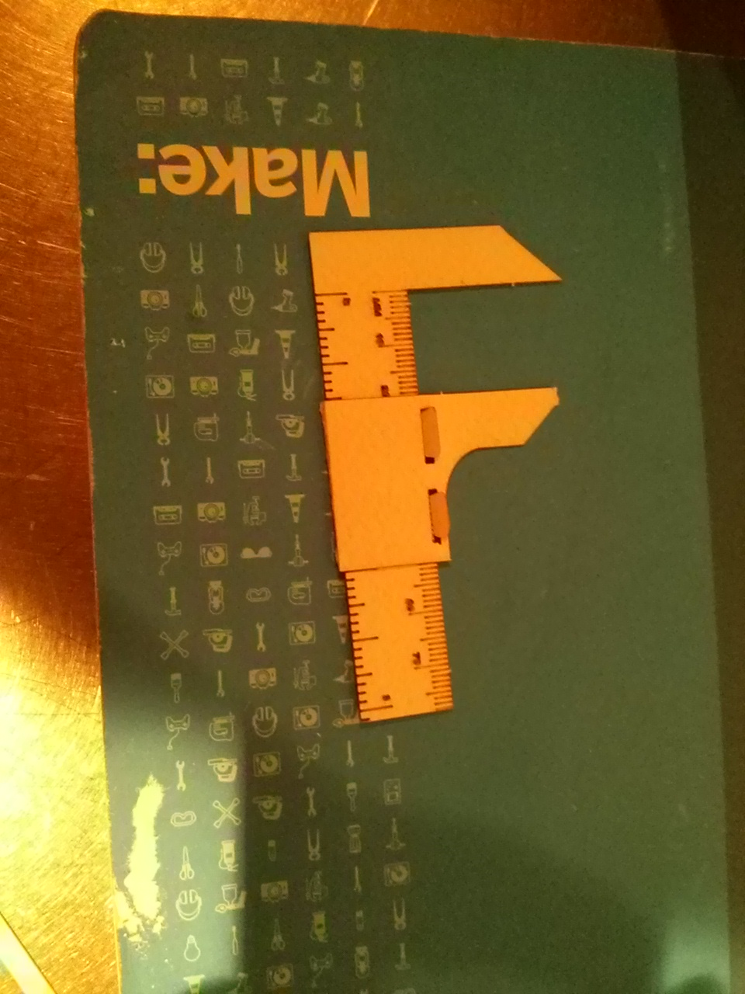

## Turning on the lights

1. The light switch to the workshop is found on a powerbar near the back left (if you’re standing in the doorway, facing in) corner of the shop.

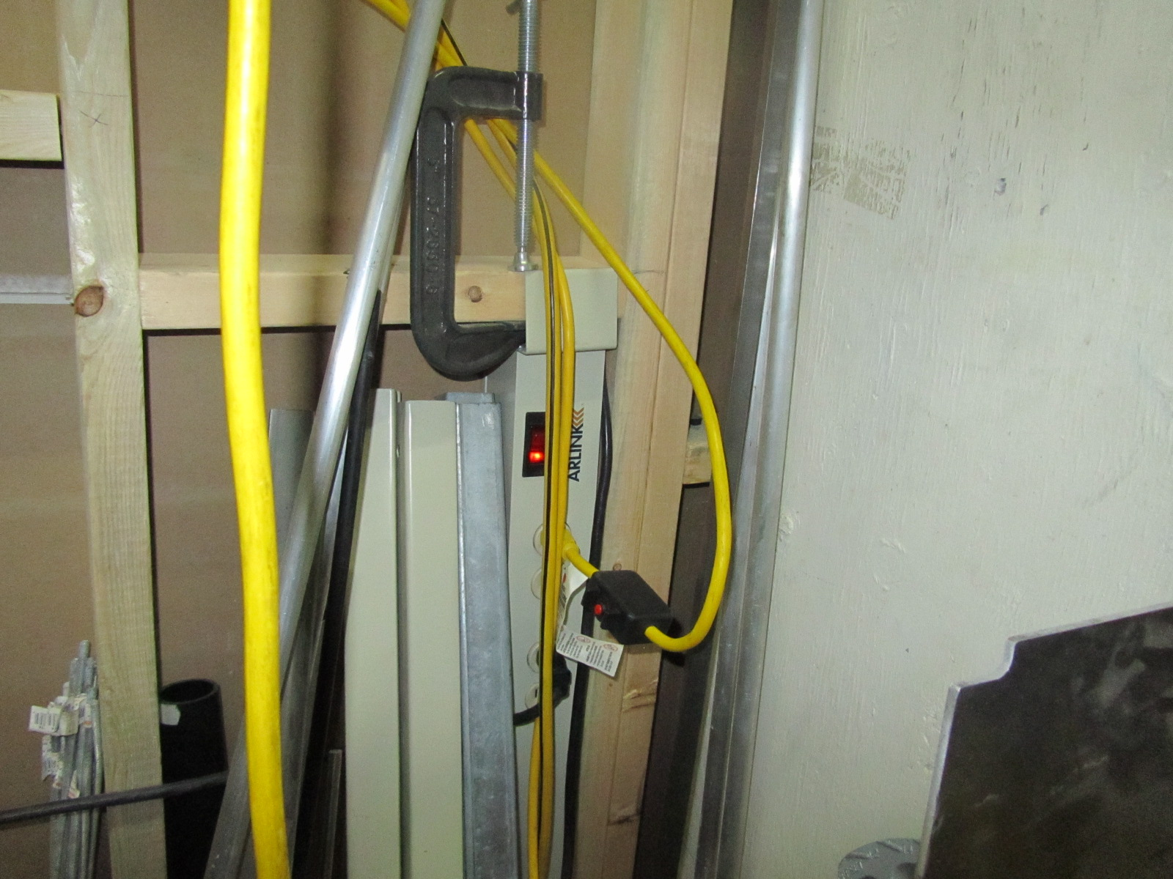

1. Next, turn on the lights for the laser room. This will also give power to the fan in the laser room, as well as the computer. This switch is in the laser room, on a powerbar at the back of the bench.

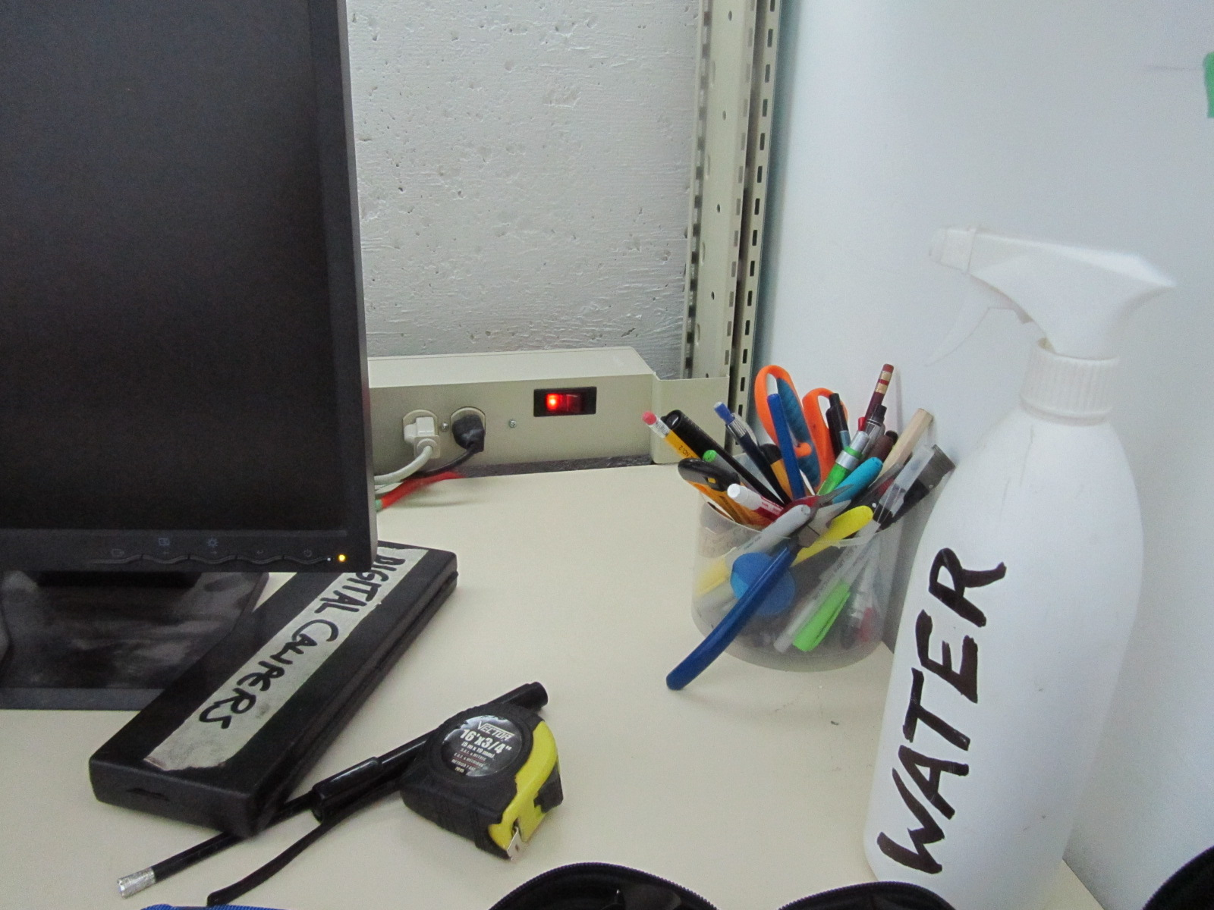

## Preflight Check

At this point, it’s important to take a good look around.

**Failure to properly check the below items can damage the laser.**

Check the following:

1. Are there Notices of Trouble, or Out-Of-Service signs around the laser or on the Laser white board?

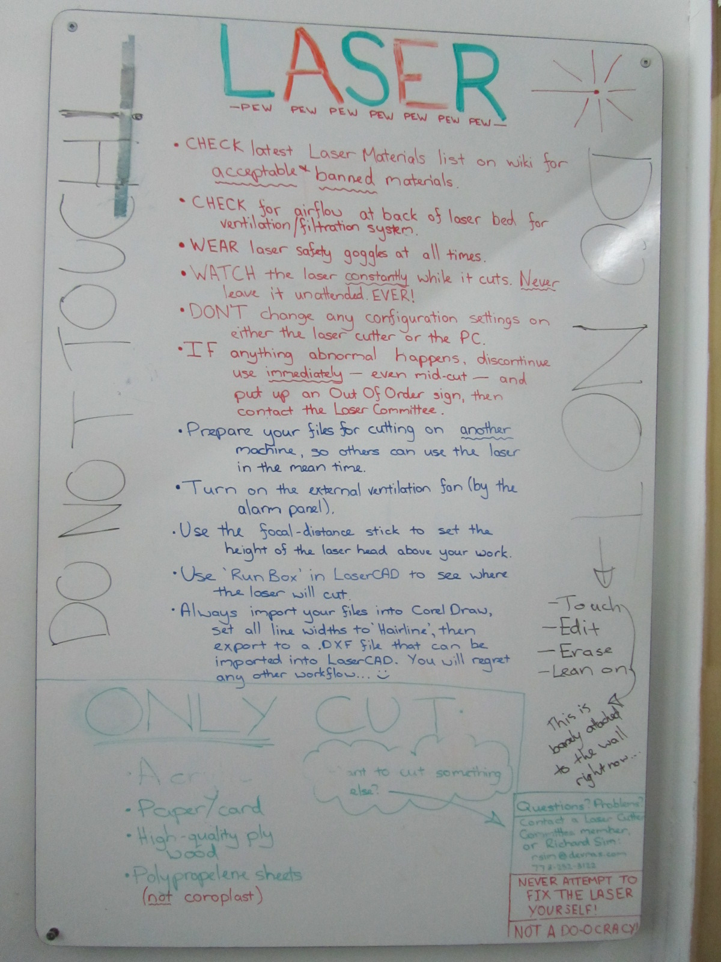

1. Is the laser cutter bed clear of material?

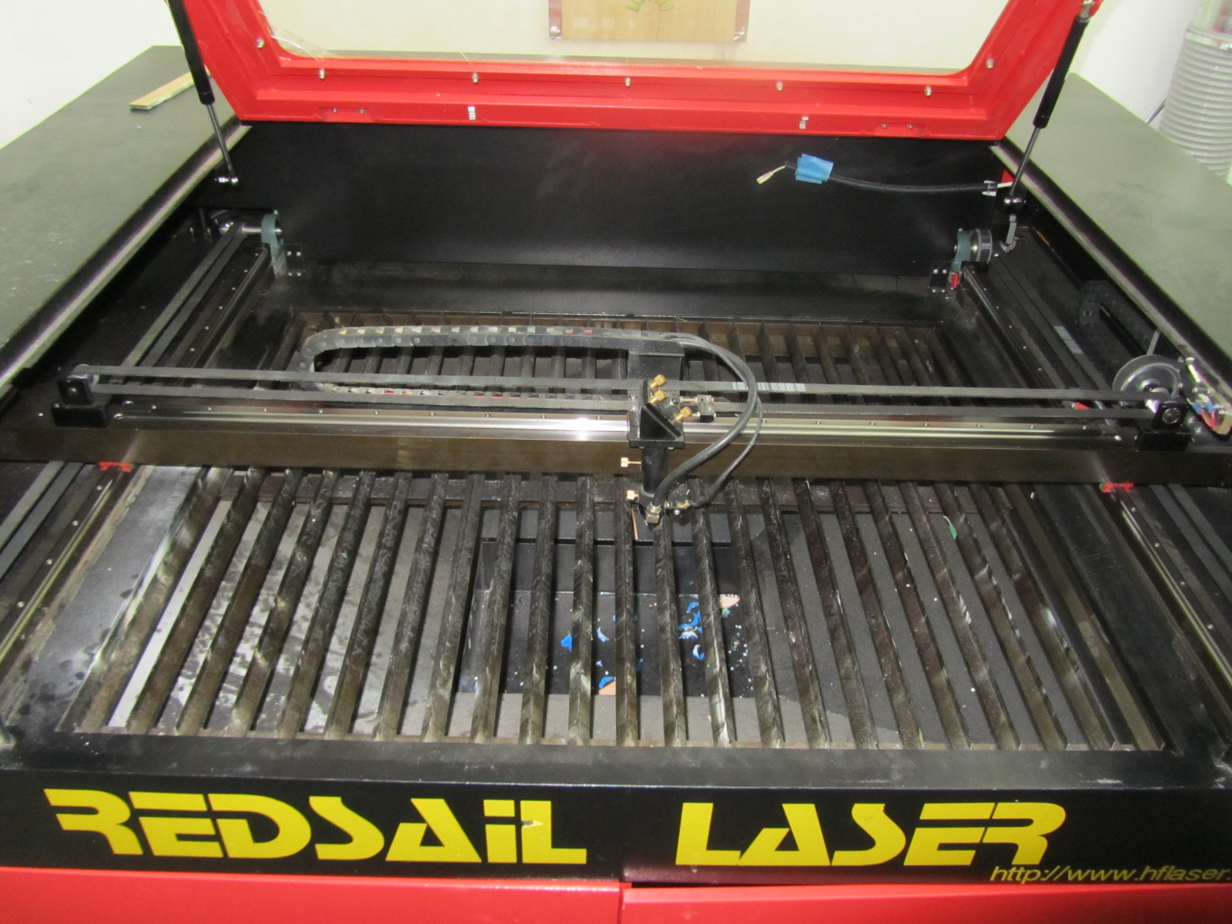

1. Is the catchement tray empty?

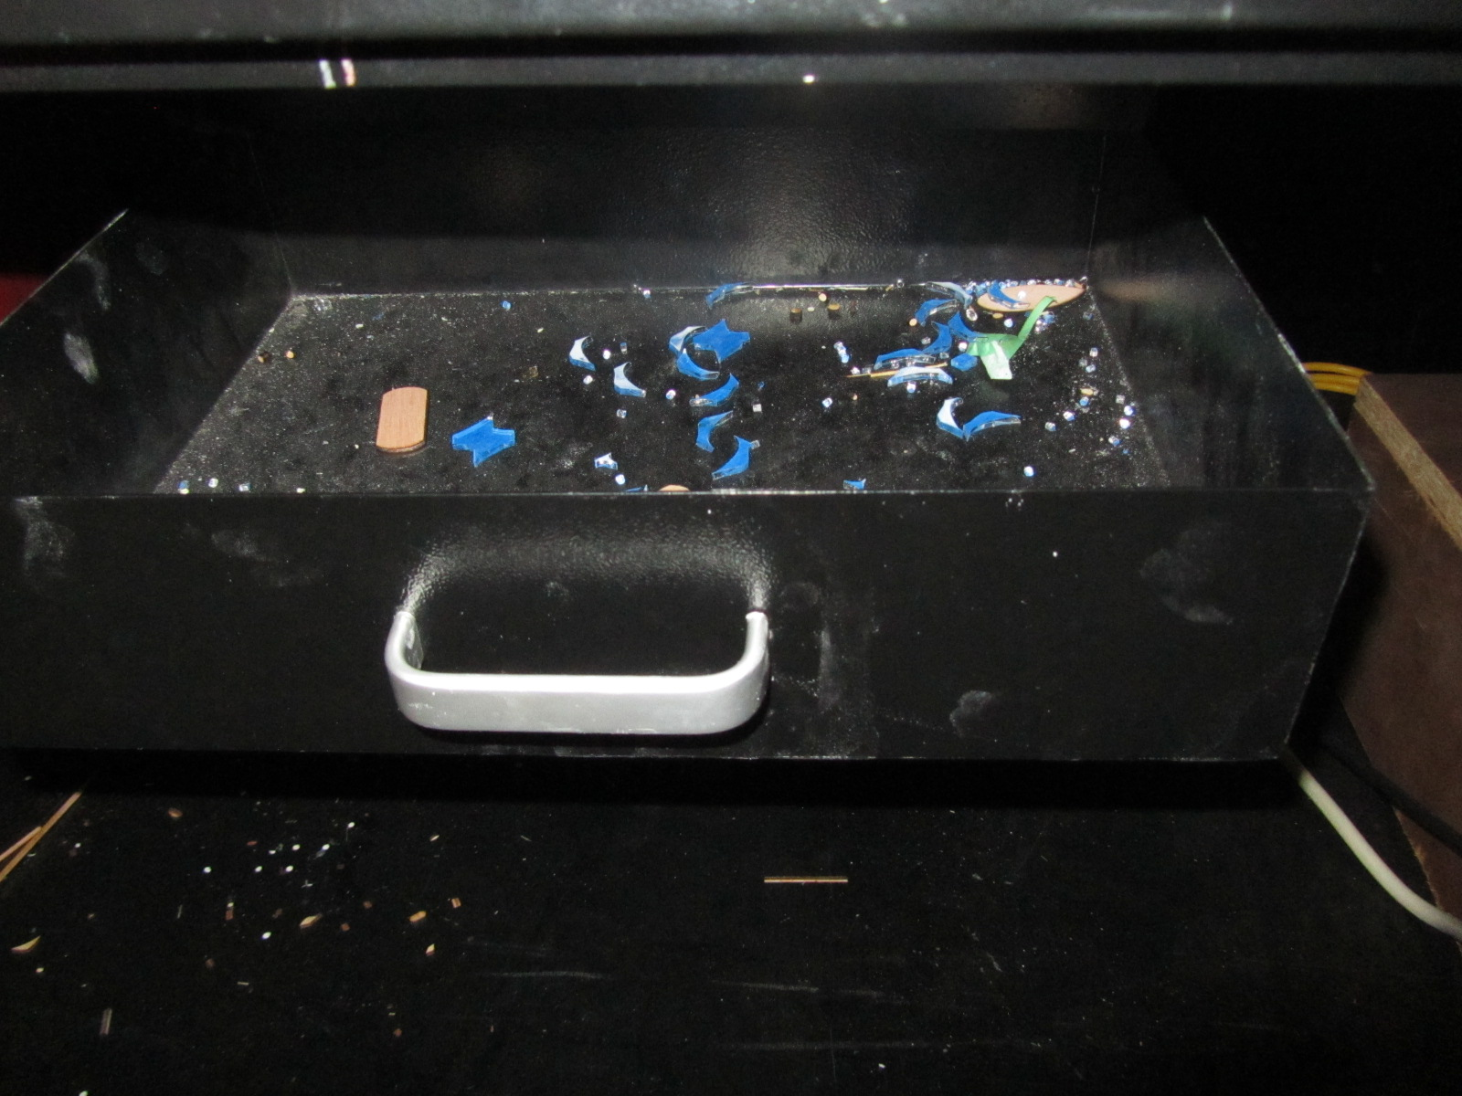

1. Is the vent at the back of the laser clear of dust, etc? You should be able to feel the air flowing into the vent. If the airflow is restricted, use the blue paintbrush to sweep the grate clear of debris.

*You can see that the vent below is in need of cleaning.*

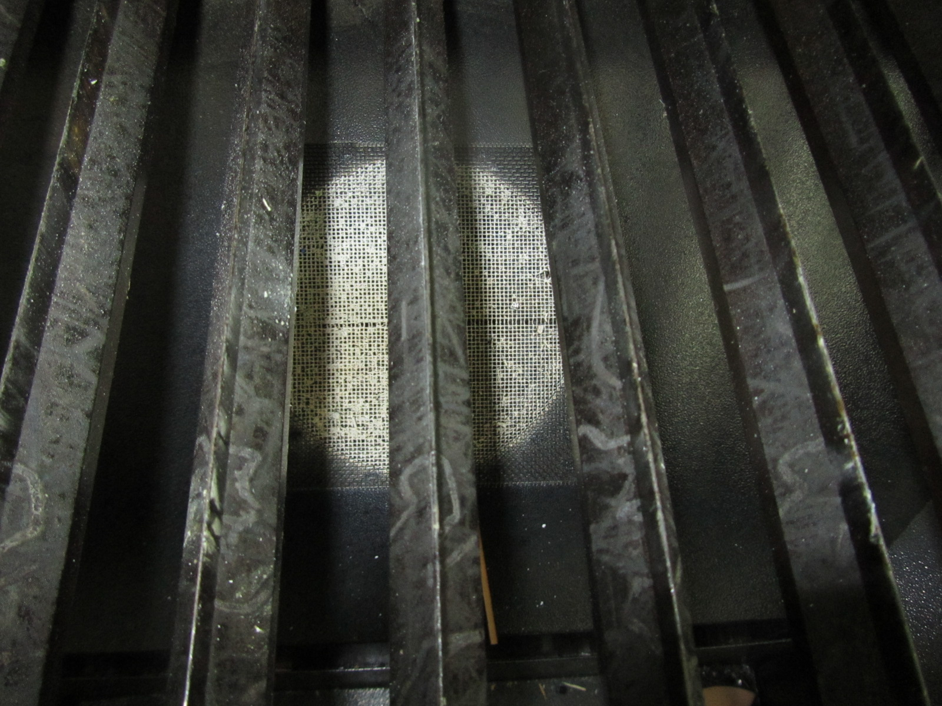

# Using the Laser Cutter

Once all the above has been checked, we are ready to run through the laser cutter startup procedure.

## Warm up the Laser

Now that the laser has been examined, it’s time to warm it up.

1. Close the lid.
2. Make sure the Emergency Stop button is not activated. If it is, GENTLY twist it to de-activate .

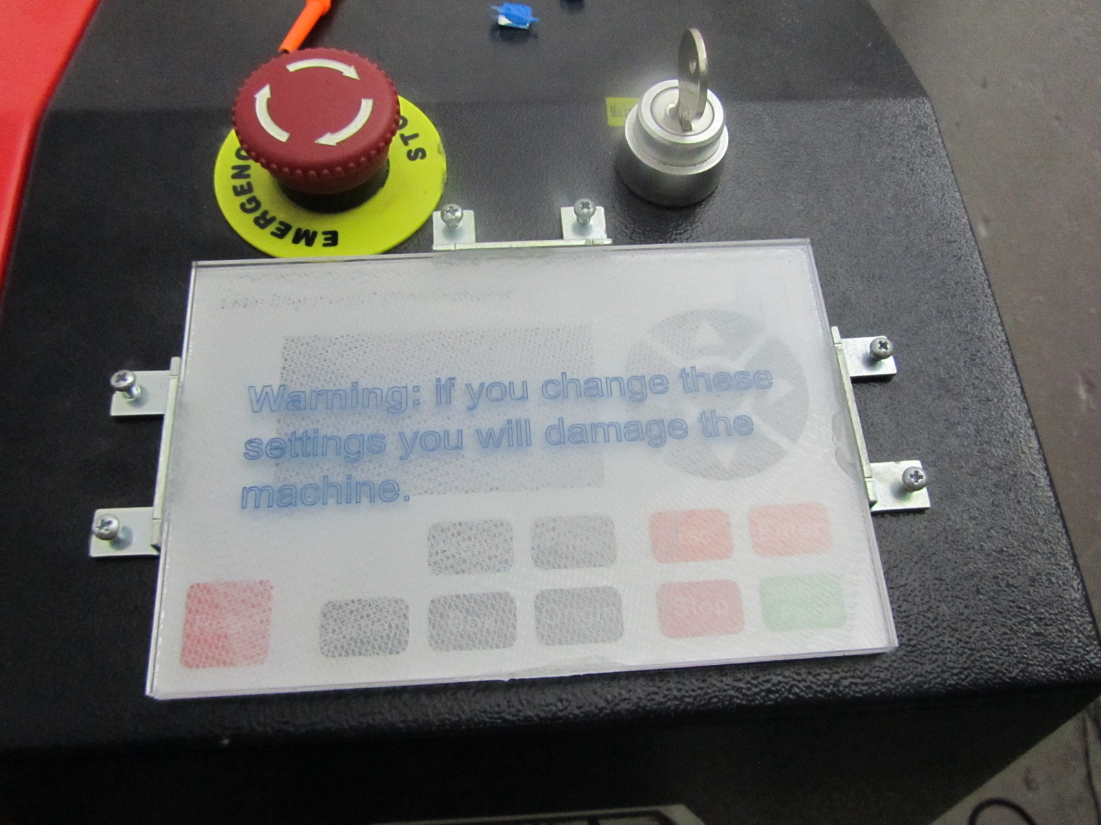

**Do not touch any other settings directly on the laser other then the key and the emergency shut off. Doing so will damage the machine.**

1. Turn on the power switch to the transformer box, located in the bottom right of the laser cutter cabinet. The water cooler should beep as it starts. The air-assist pump will also start.
2. Turn on the main power key on the top-right of the laser cutter.

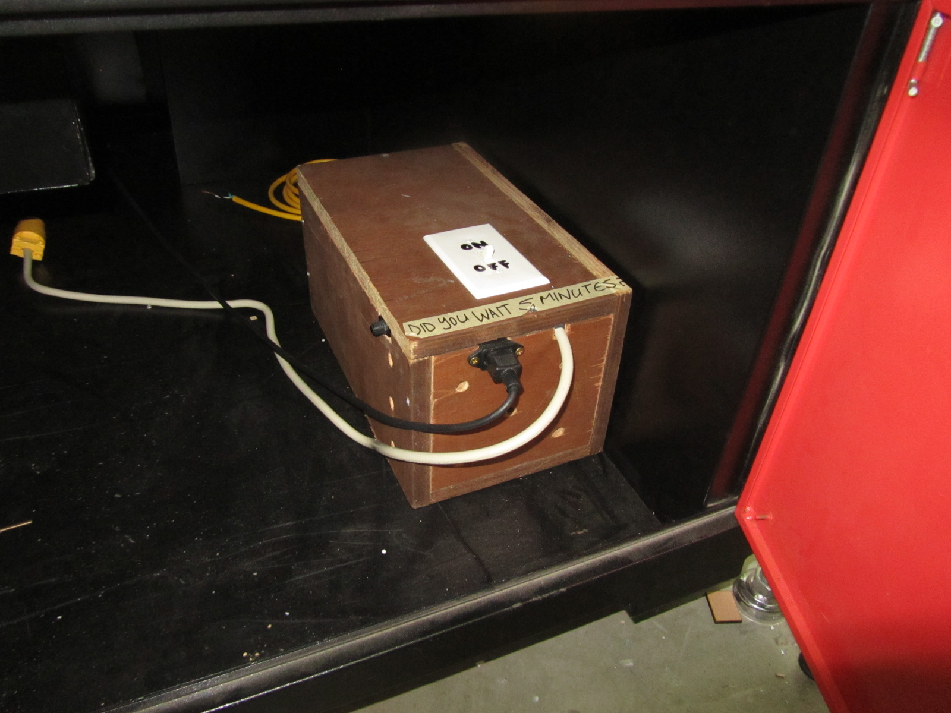

1. Turn on the external fan. The switch is located near the back door. Push the toggle up to turn the fan on.

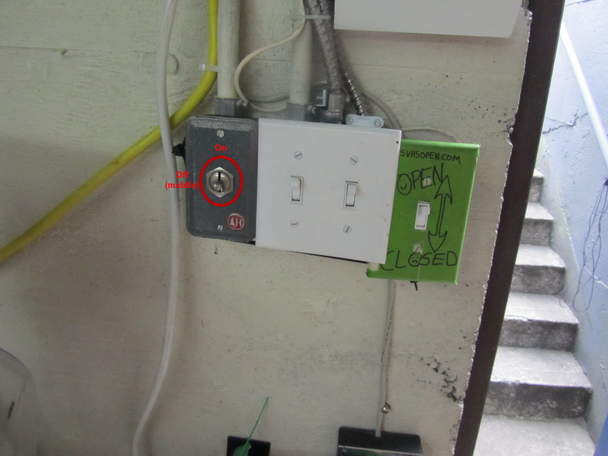

1. Wait 5 minutes after power-on, as the water cooler must get the water chilled and evacuate all air bubbles from the laser tube.

**Failure to wait the proper amount of time will reduce the life of the laser.**

1. Power up the computer.
2. Put on the laser safety glasses. Do not take them off until the laser if powered down.

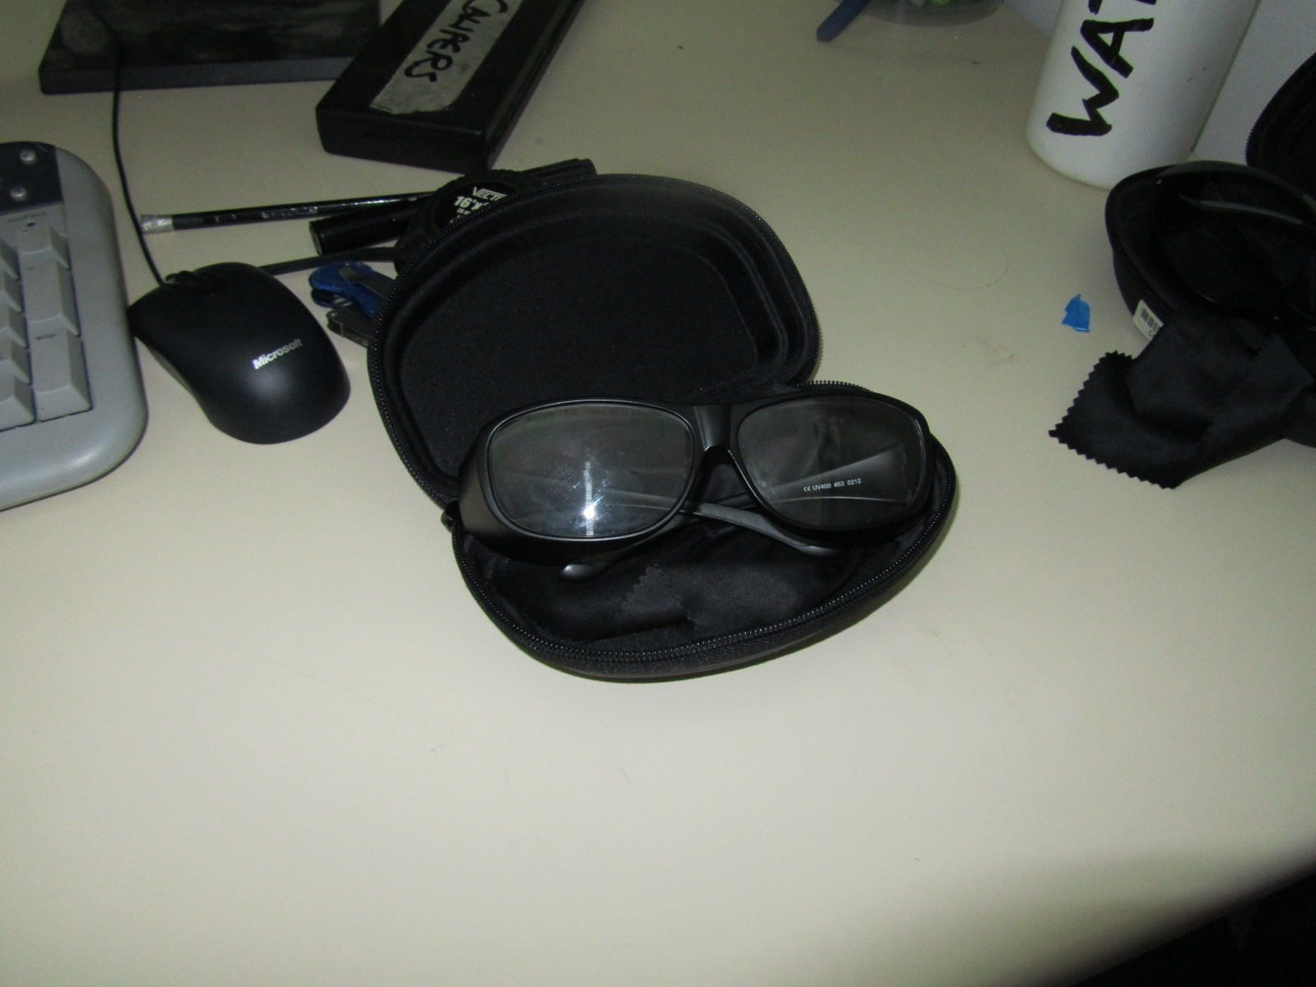

**Lasers LOVE eyeballs! Protect your eyes at all times!**

## Setting up the Material

This course will use approved card stock. For a complete list of approved material, see the VHS Wiki at <https://vancouver.hackspace.ca/doku.php?id=laser_cutter_settings>.

It’s a good idea to have some test pieces to see how the material will react to various speed and power settings as we will see later on.

The next step is to focus the laser. In order to do this, you will require the green acrylic focus tool. This tool is used to establish the correct distance between the top of your material, and the bottom of the laser. This will ensure it focus’ correctly.

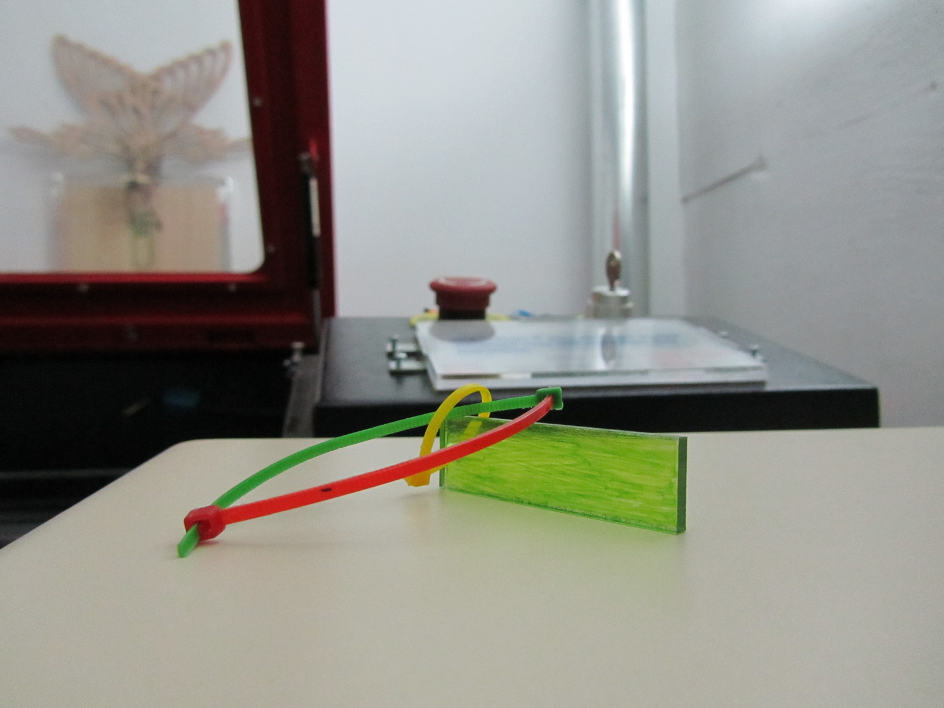

1. Place your material on the cutting surface under the laser. Loosen the top thumb screw, but be careful not to let the laser head free fall! Place the focus tool on top of your work piece, then rest the laser on top. Tighten the thumbscrew in place and put the focus tool back where it belongs. This process is the same, regardless of the material being cut.

*Remember to change the focus if you change the thickness of material you’re cutting.*

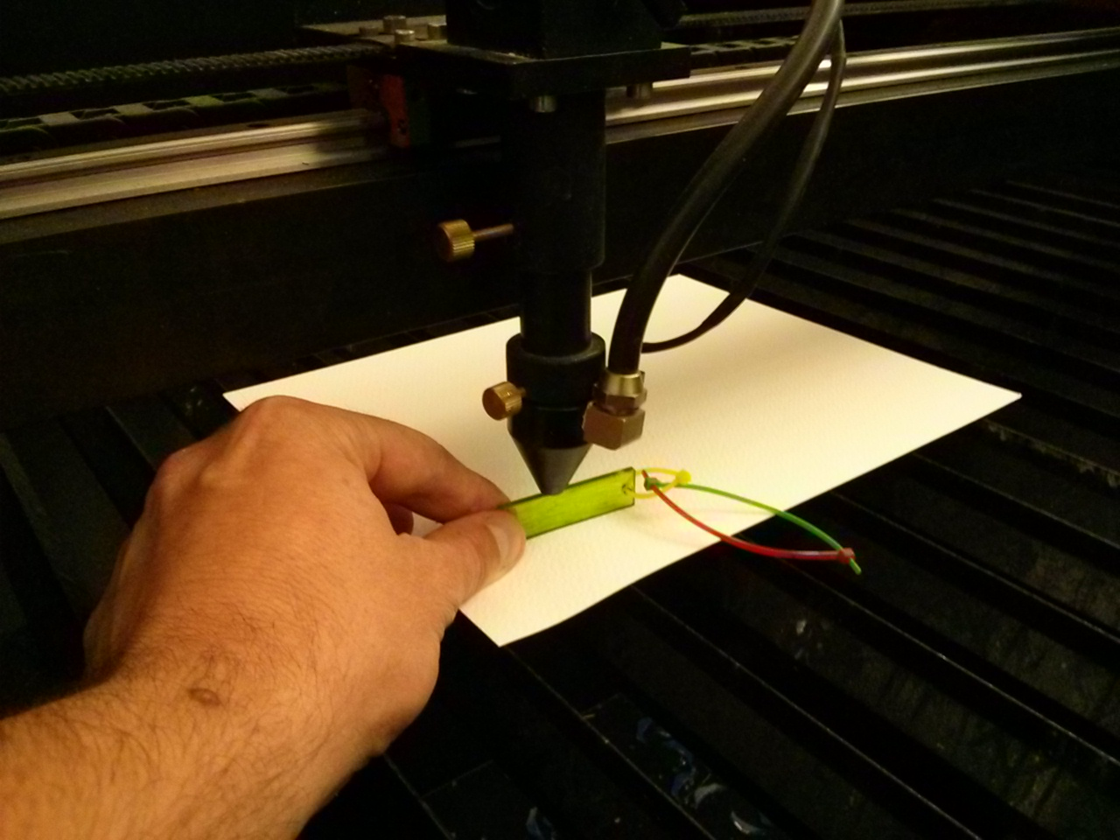

1. Once the laser is focused, move your material to the centre of the table. It may have to be adjusted later.

**Do not touch the mirrors or lens of the laser cutter. If they are dirty, please discontinue use of the laser cutter immeadiately and let the Laser Cutter Committee know. Using the laser cutter with dirty mirrors could ruin them.**

1. Close the lid! Keep the door to the laser cutter room open, as this helps with the ventilation.

## Emergency Procedures

Before you start cutting, review these emergency procedures.

Flair ups: Flare-ups happen frequently when using a laser cutter; it's simply the nature of the tool. Most flare-ups will self-extinguish as soon as the laser beam (the heat source) has moved away from the area being cut, or if the laser is turned off (by completing the cutting job, the Stop or Pause buttons being pressed, or by pressing the Emergency Stop button).

If a flare-up has been going for more than a few seconds, or shows any signs at all of fully igniting or burning through the material, immediate action must be taken to stop the fire. Your material/work piece is lost at this point - act quickly and do not hesitate.

1. Hit the Emergency Stop button on the control panel of the laser cutter (the big red button on the front-right corner).
2. Douse the area with the spray bottle.

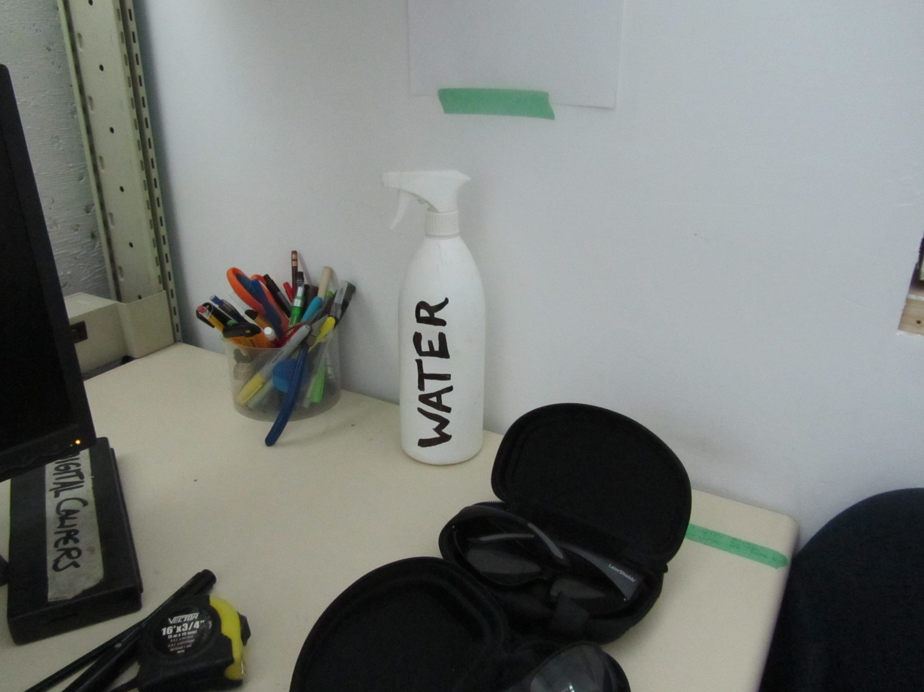

1. If the spray bottle proves insufficient to extinguish the fire, use the fire extinguisher immediately. The fire extinguisher is to be used as a last resort at it will damage the laser cutter.

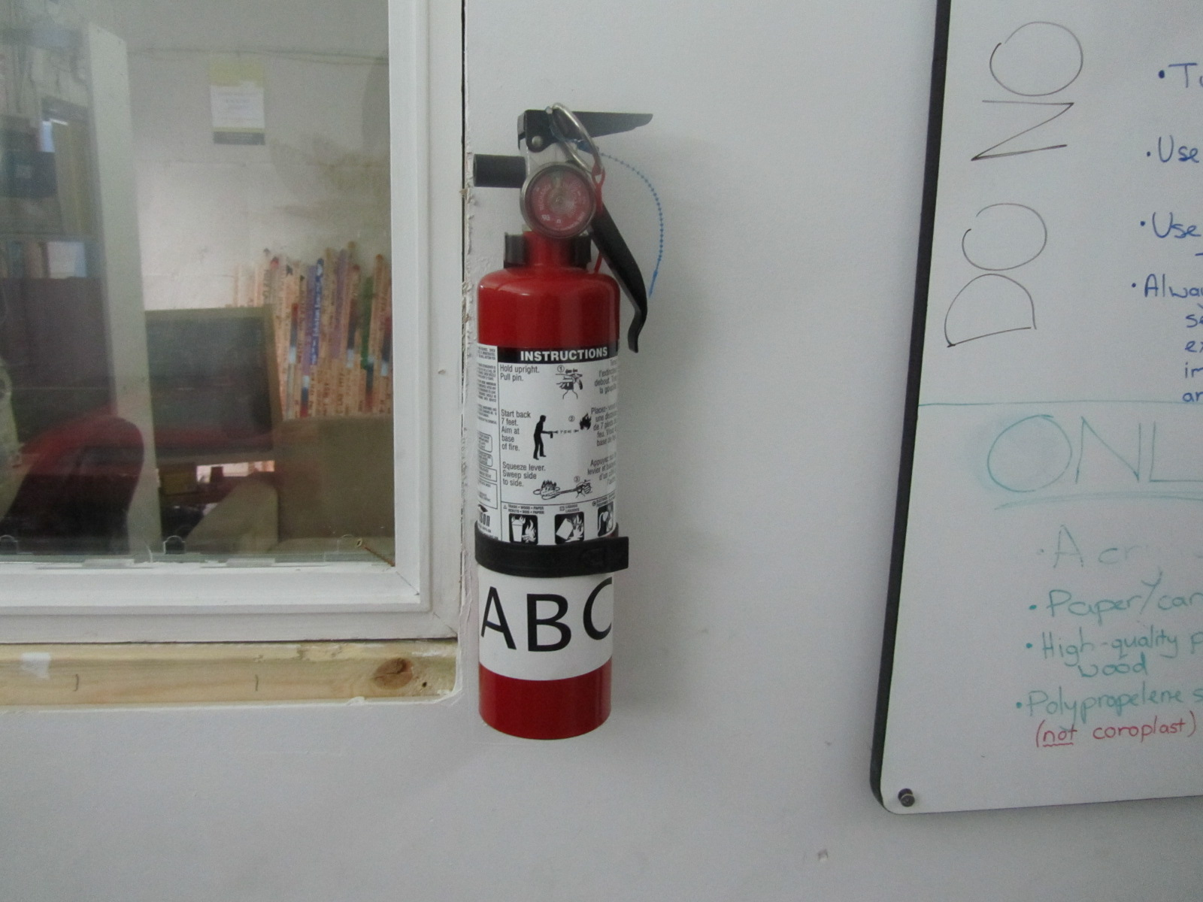

## Importing the File

Now we will create the file that will tell the laser what to cut and how to cut it.

1. On the laser cutter computer desktop, there is a folder called Laser User Files. Browse to this location, and create a folder with your name. This folder is where all your laser cutter files will be kept. Do not put personal files anywhere else on the computer.

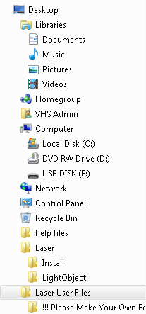

1. In the Laser User Files folder, browse to Laser Cutter Training. In here, you will see a file called ‘business_caliper.dxf’. Copy this file to your personal folder so you don’t overwrite the original.

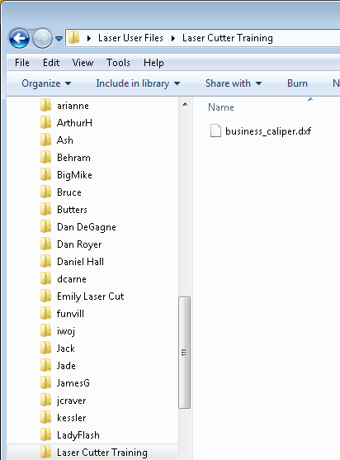

1. Start LaserCad.

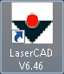

1. Import your personal copy of the file ‘business_caliper.dxf’ by selecting Import, under the File menu.

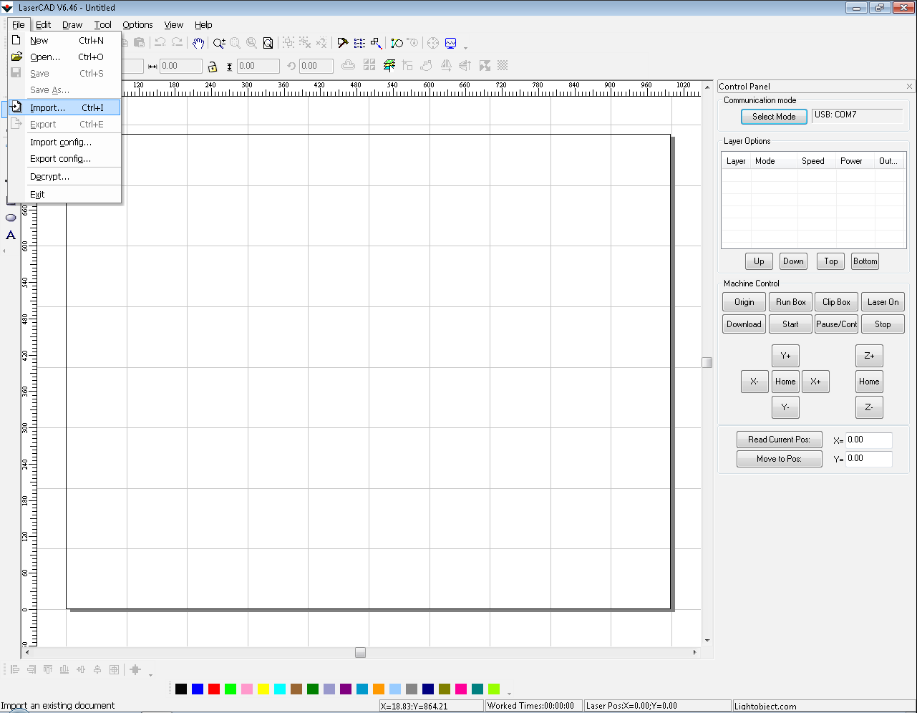

1. Then browse to your copy of business_caliper.dxf.

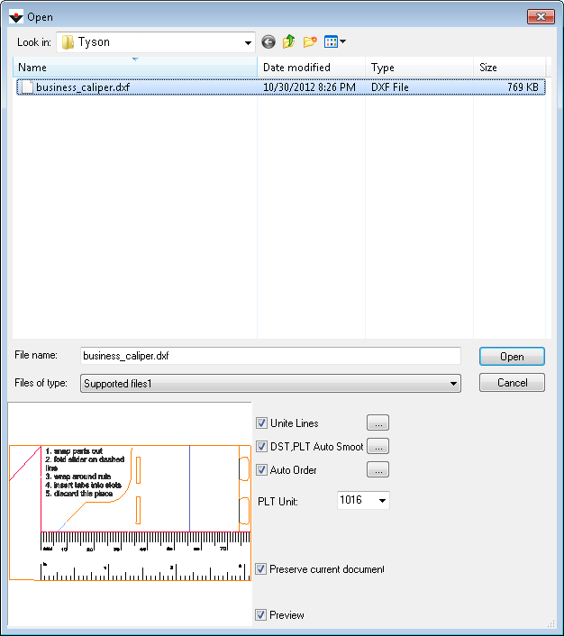

1. Click Open to import the file.

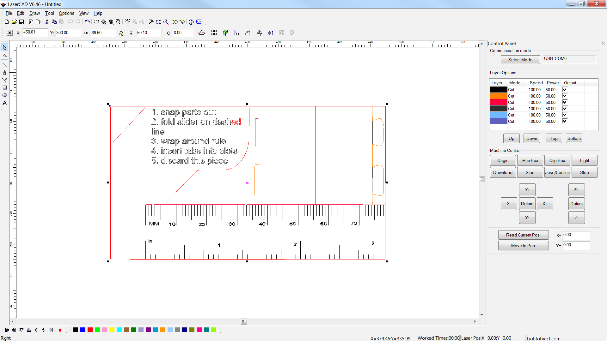

Notice that the file is already broken down by colour. Each colour represents a layer, with it’s own power and speed setting. If you zoom out ( & right click), note that the image appears in the centre of the canvas. This canvas represents the bed of the laser cutter. So when we setup to cut this, the material must be placed in the centre of the bed. If the image was moved to the lower left of the canvas, the material would have to be moved to the lower left of the laser cutter bed. Later, you will use the Run Box utility to ensure that the material is placed properly.

## Setting up the Layers

When the piece is being cut, the laser starts at the top of the layers, and cuts everything on that layer. Then it moves to the next layer. When that is done, it continues down the list until finished. One issue with this file is that there are a few layers that are very close in colour. This makes it difficult to determine which layer some lines belong to. Let’s change some of the layer colors.

1. Select all features on the orange layer by clicking the ‘Select By Color’ button . From here, select the orange layer, and click OK.

*Note: in some menus, this is also called ‘Select By Layer’*

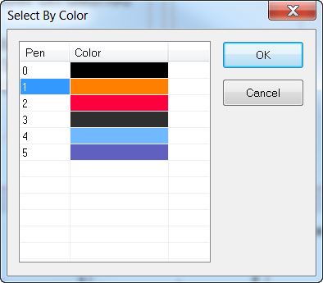

This has selected all the orange lines in our file. Now we can change them to a colour that is a bit more easy to distinguish from red.

1. On the colour bar on the bottom, click the light green.



By doing this, two things will happen:

1. all the orange lines change to green,

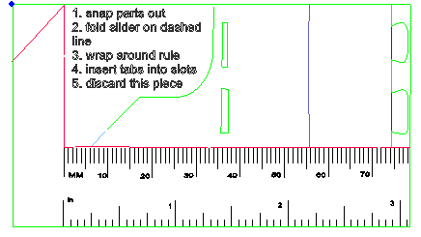

1. the layer will move down to the bottom of the list.

*The fact that the layer moves appears to be a bug in the software.*

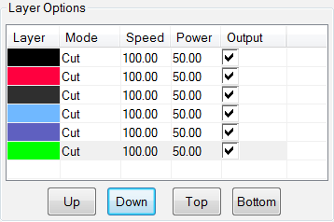

1. Separate the two colors that both look black. Follow the above steps to select the lines in the layer third from the top, and change them to teal .

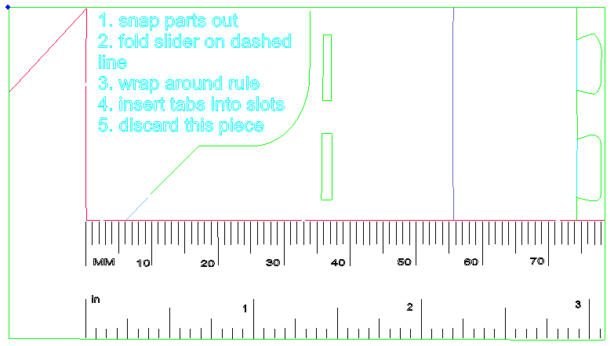

All the colours are easily distinguishable.

Now that the orange lines have turned green, we can see some issues with our card. The issue is that the outside edge is on the same layer as some of the inside parts and consequently, we can not enforce which lines will get cut first. If we were to cut the outside edge first, the piece could fall loose, or shift. To remedy this, we will change the colour of the outer edge to put it on it’s own layer. Then we can force it to be cut last.

1. Select the outer edge, and click the dark green button . The outer edge will turn dark green, and a new layer will be added at the bottom.

*Ideally, this would have been caught in the design stage, and fixed in the DXF.*

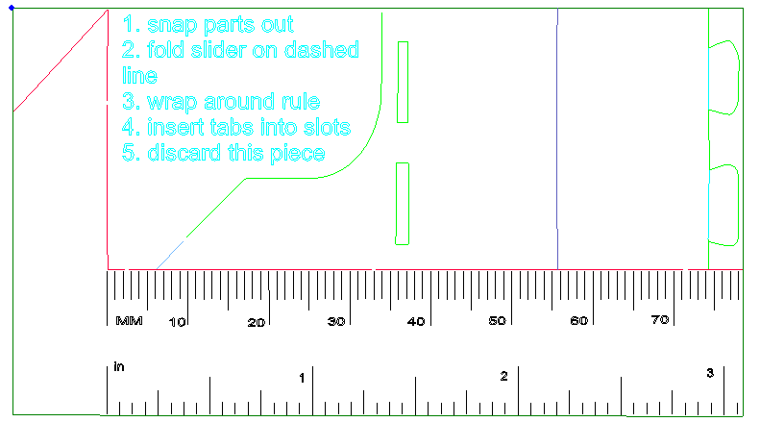

Note the light blue line below the teal text. While strictly speaking, this is not an issue, we can clean up the design a bit by changing it to light green. Since it gets cut at the same time as the light green layer, there’s no benefit to having it on it’s own layer. Once we change it to light green, the light blue layer will disappear from our design. This means there will be one less layer to set the power and speed for.

1. Select the light blue line. Once it’s selected,click the light green button. The colour will change, and the light blue layer will disappear since there are no longer any lines with that colour.

*Q: How would you merge entire layers? Are there any layers that can be merged? Why?*

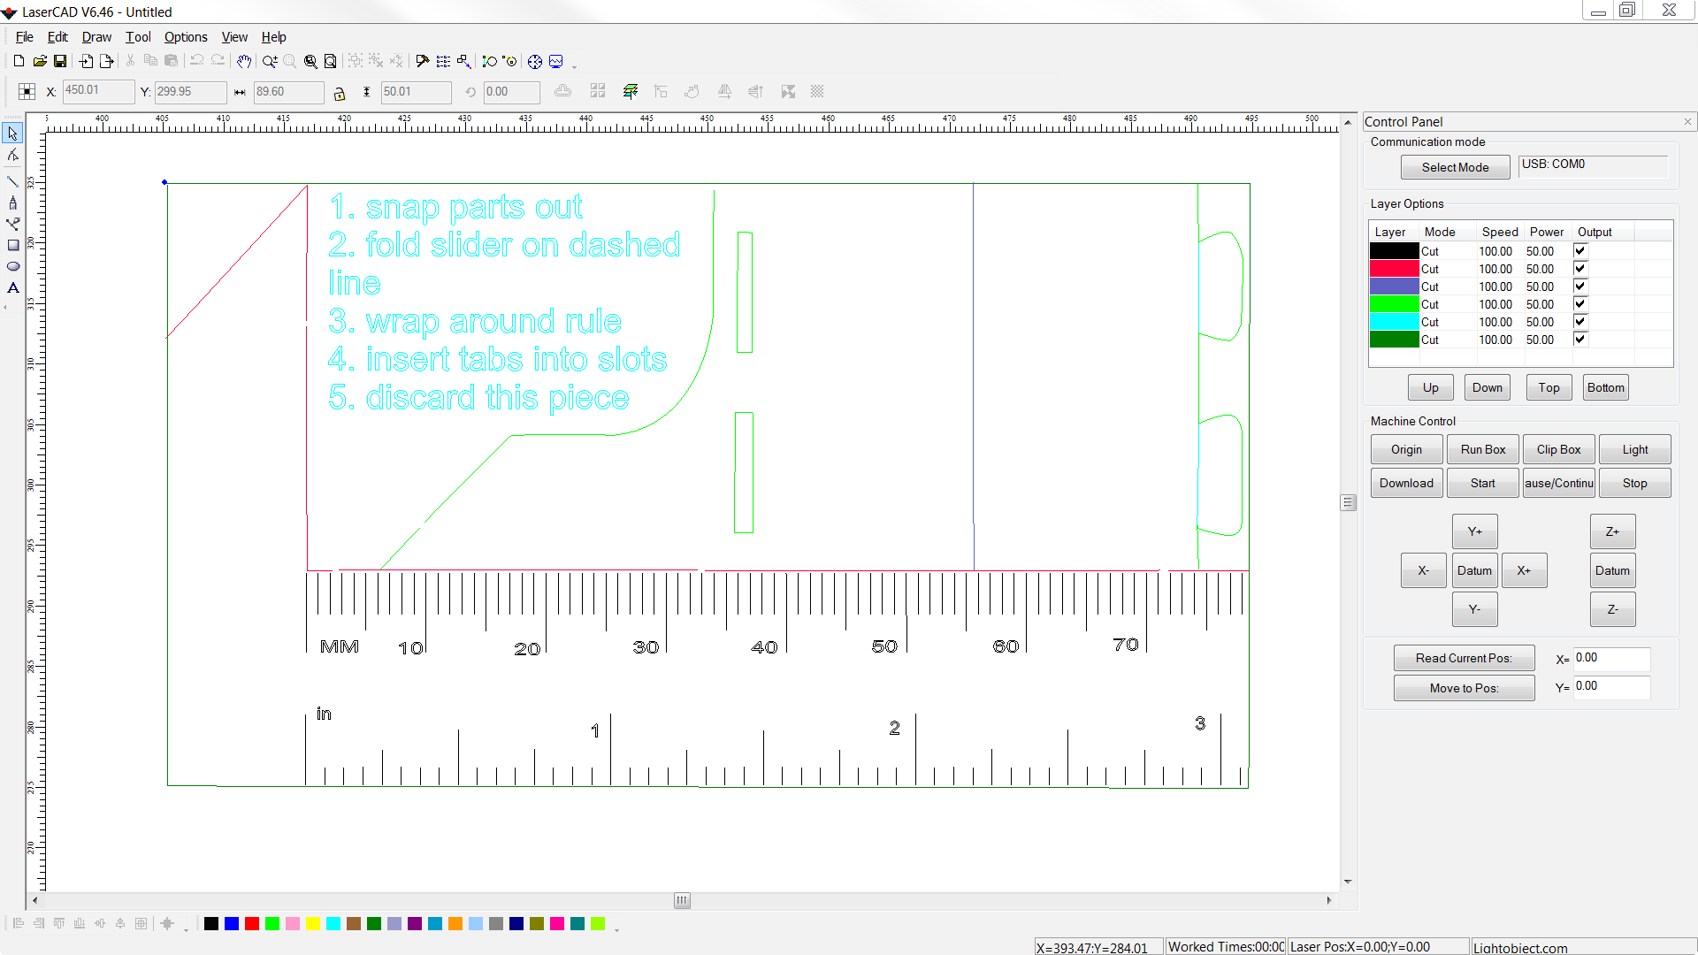

Now we can take a look at the layer order. Generally, the process is to have the etched layers go first, then the cuts, starting from the interior and working your way to the exterior. For this piece, we’ll want to etch teal, light green, black, and light purple, then cut red (our first inside cut), then dark green (our outer edge).

1. Select the layers and change the order by using the Up, Down, Top, and Bottom buttons.

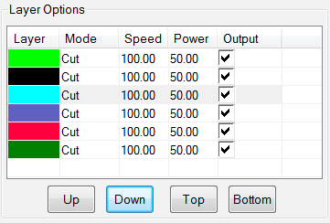

*Q: Does the order of teal, light green, black, and light purple layers matter?*

Once the order is correct, it’s time to review the power and speed settings. The Power setting determines the strength of the laser, and the Speed is how fast the laser head will travel. Both of these together affect the cut. The correct settings are determined by the density of what you’re cutting, the thickness of the material, and the desired effect (cut or etch).

Another factor that plays into the equation is the location on the laser cutter bed. Due to the design of the optics and their distance from the laser, some spots in the bed will cut more easily then others. Generally, the left side appears stronger then the right side. There is no mechanism in the software to account for this.

The best way to determine what settings to use is to have a piece of test material. Then run a test pattern of small circles, all with different speeds and powers.

**NOTE: Do not set the power highter then 80. It will cause undue stress on the laser tube, and shorten its life.**

Luckily, laser cutter users have been keeping track of settings for various material. This information is on the wiki at:

<https://vancouver.hackspace.ca/doku.php?id=laser_cutter_settings>

1. For the layers that will be etched, set the Speed to 40 and the Power to 10.
2. For the layers that will be cut, set the Speed to 35 and the Power to 35.

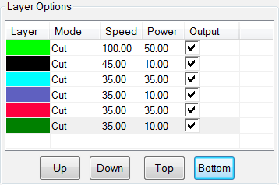

1. Once the file looks correct, save it to your personal folder.

## Cutting

Now we are ready to download the job to the laser cutter.

1. Click the Download button to load the file to the laser cutter .
2. From the Download Document screen, click the Download Document button.

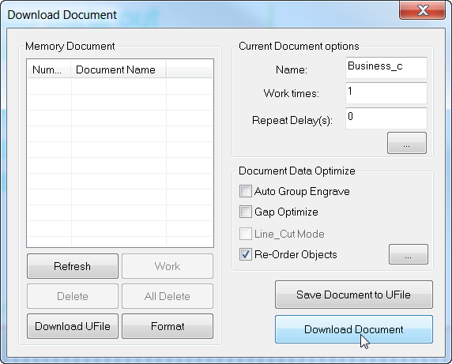

1. Once the download is compelet, click the Run Box button 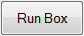. This will use the laser pointer on the laser cutter head to draw the outline of the extents of the job. If these extents run over the edge of your material, you should reposition the material. This is a good chance to catch any mistakes involving material placement or scale.
2. If the Run Box extents look correct, then click the Start button . This will start the laser cutter, and cut the material.



**Do not leave the laser unattended. Not even for a second. Watch the job the entire time.**

NOTE: If you notice a problem with the way that your cut is going (perhaps the layers are out of order and the material has fallen through the grate, or the scale is off), the job can be safely aborted by clicking the Stop button . **Do not hit the emergency stop button, do not turn the key off, and do not shut down the power to the laser! The emergency stop button is only for emergencies.**

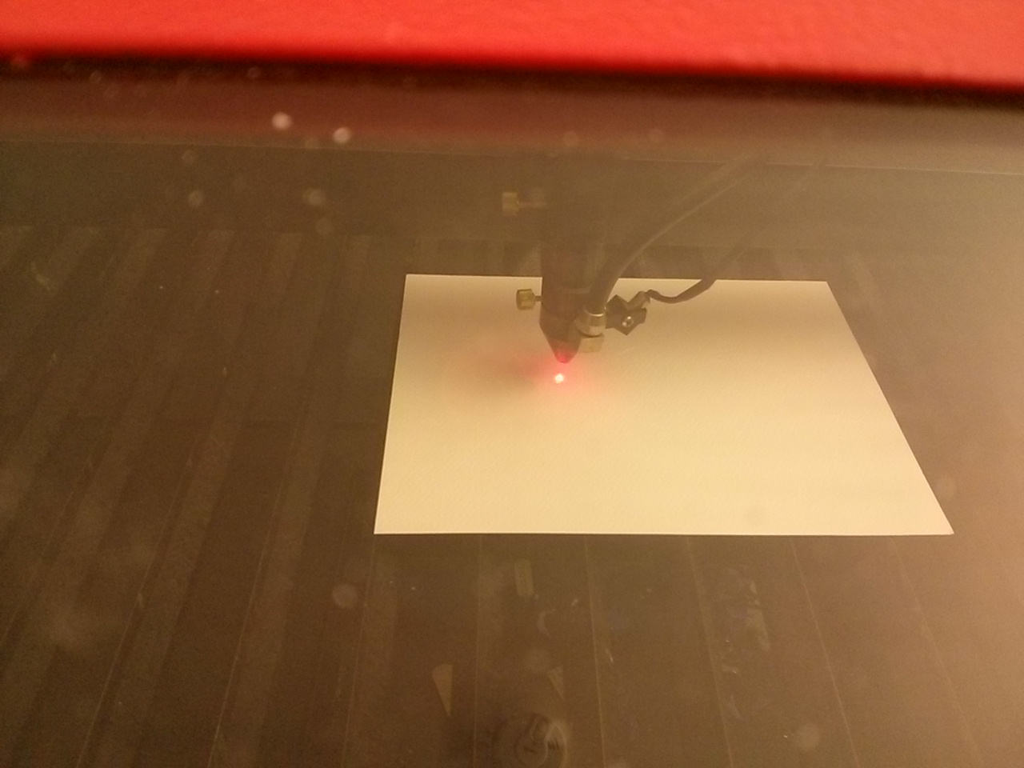

1. Once the job has been completed, the laser will beep and return to its starting position. It’s now safe to retrieve the piece.

**Do not lift the lid until this happens.**

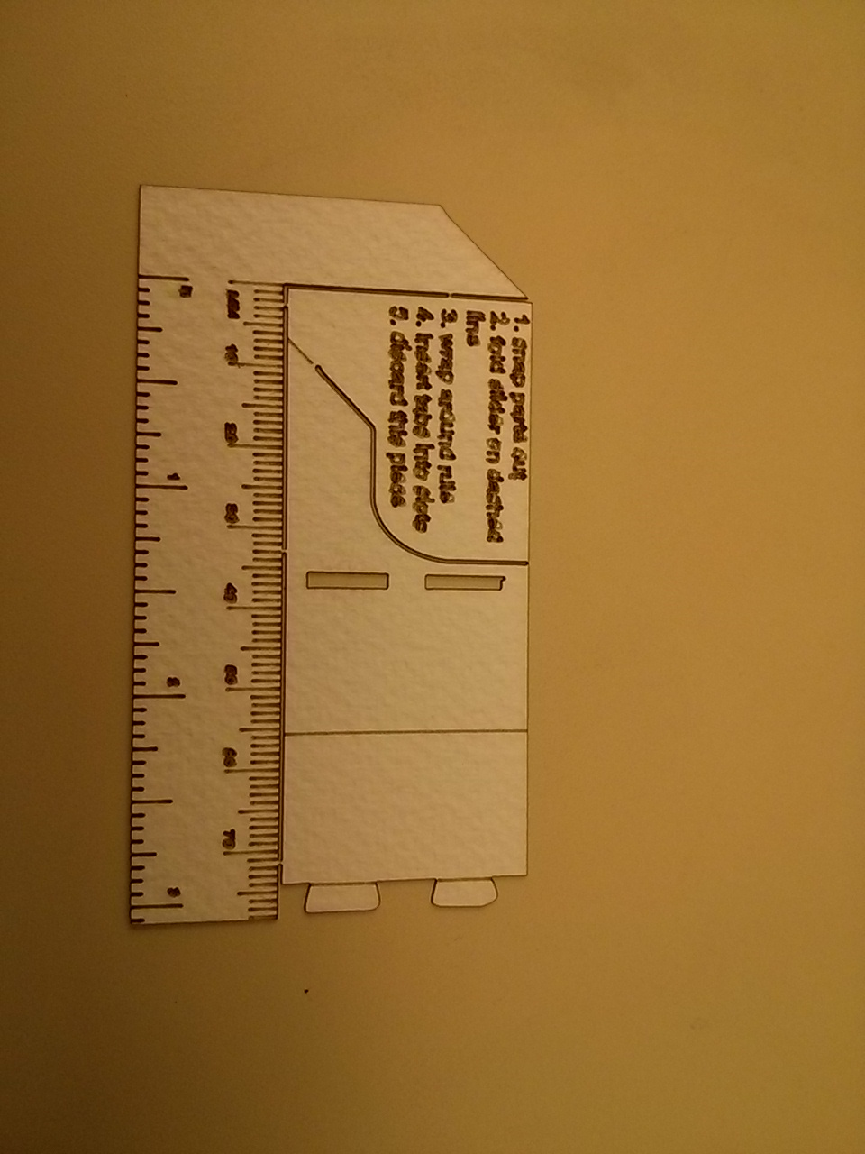

## Shutting Down the Laser

Now that the work is done, we can begin to wrap things up.

1. Clean up! Since you wait the five minutes for the laser to cool down anyway, this is a perfect opportunity to:

* Remove all your scraps from the bed and catchement tray.
* Put back any calipers, or other tools that have found their way into the laser room.
* Eject your USB stick.
* Put back the laser safety glasses. Clean them if they’re dirty!

1. Power down the computer.
2. Shutdown the exterior fan. This is the toggle switch by the door.
3. If **at least** 5 minutes has passed, turn the the laser cutter key to off.
4. Turn the power switch on the transformer box to Off.

# Advanced Techniques

This section contains some more advanced features of the LaserCAD software.

## Changing the Scale

Changing the scale in LaserCad is not as straight forward as some other packages. To change the scale, first lock the Proportial Scale by clicking the button . Select the entire drawing. The current size will be shown in the Object Size boxes.



To change the scale, change the number in one of the size boxes. The other size should also change by the same scale factor (though there is often a little variation). To double the scale of the example above, you would enter 1.6 in the X scale. The Y scale changes automatically.



## Multiple Passes

Multiple passes can only be set on a drawing level, and not on an individual layer level. They are set when the job is downloaded. In the Download Document window, specify the number of times the job should run in the ‘Work Times’ box.

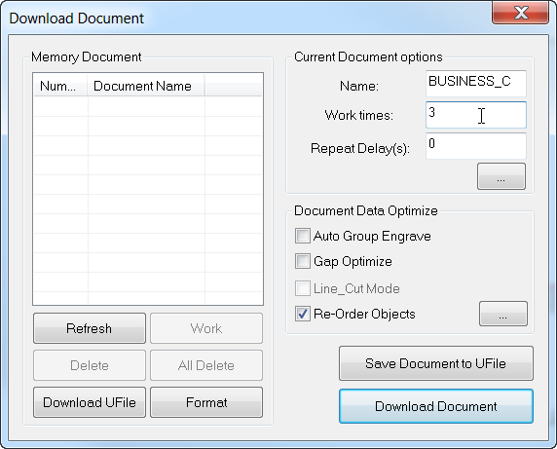

## Disabling Output of Select Layers

In some instances, you may not want to cut every layer in the drawing. This can be done by unchecking the Output check box on the layer before it is downloaded.

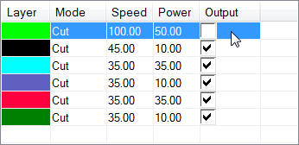

Note that even though the layers will not be cut, they are still included in the extents shown by the Run Box button.

## Automatic Line Joining

1. Cle

## Order of Cutting

For the most part, lines of a similar layer (determined by colour – see above) are cut in the order and direction that they are created. LaserCAD has the ability to overwrite order and directions. This is done from the Tools menu, under Manual Order. From here, you have the ability to change the direction and order of any line segment by selecting it, then clicking the Rev_Order button (to Reverse Order), or Rev_Dir button (to Reverse Direction).

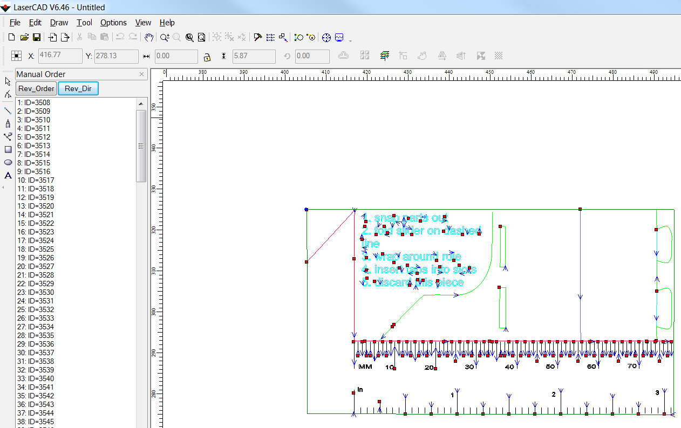

# Finishing Techniques

This In many cases, cutting the piece is only the first step towards creating your final product.

## Bending Acrylic

1. Cle

## Gluing Acrylic

Gluing acrylic is quite simple with the correct tools. The bonding agent used is Methylene Chloride. It melts acrylic rather then gluing it.

1. Pour methylene chloride into a syringe dispenser.

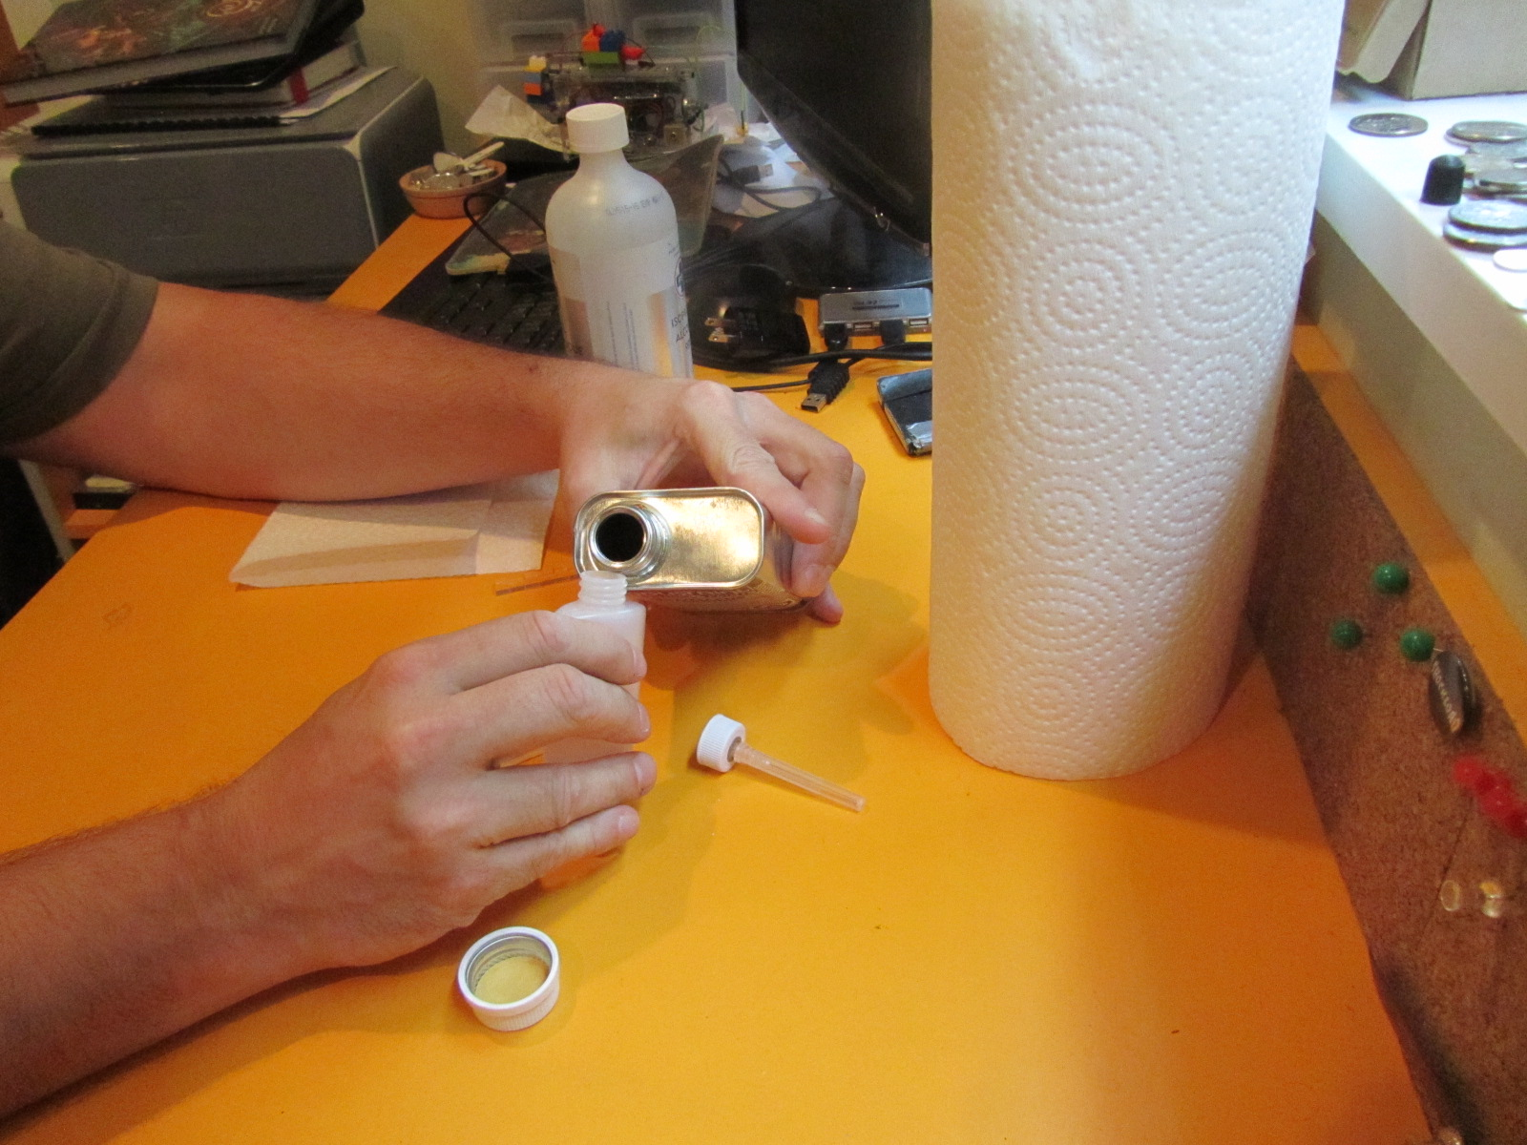

1. Clean the pieces to be glued with alchol

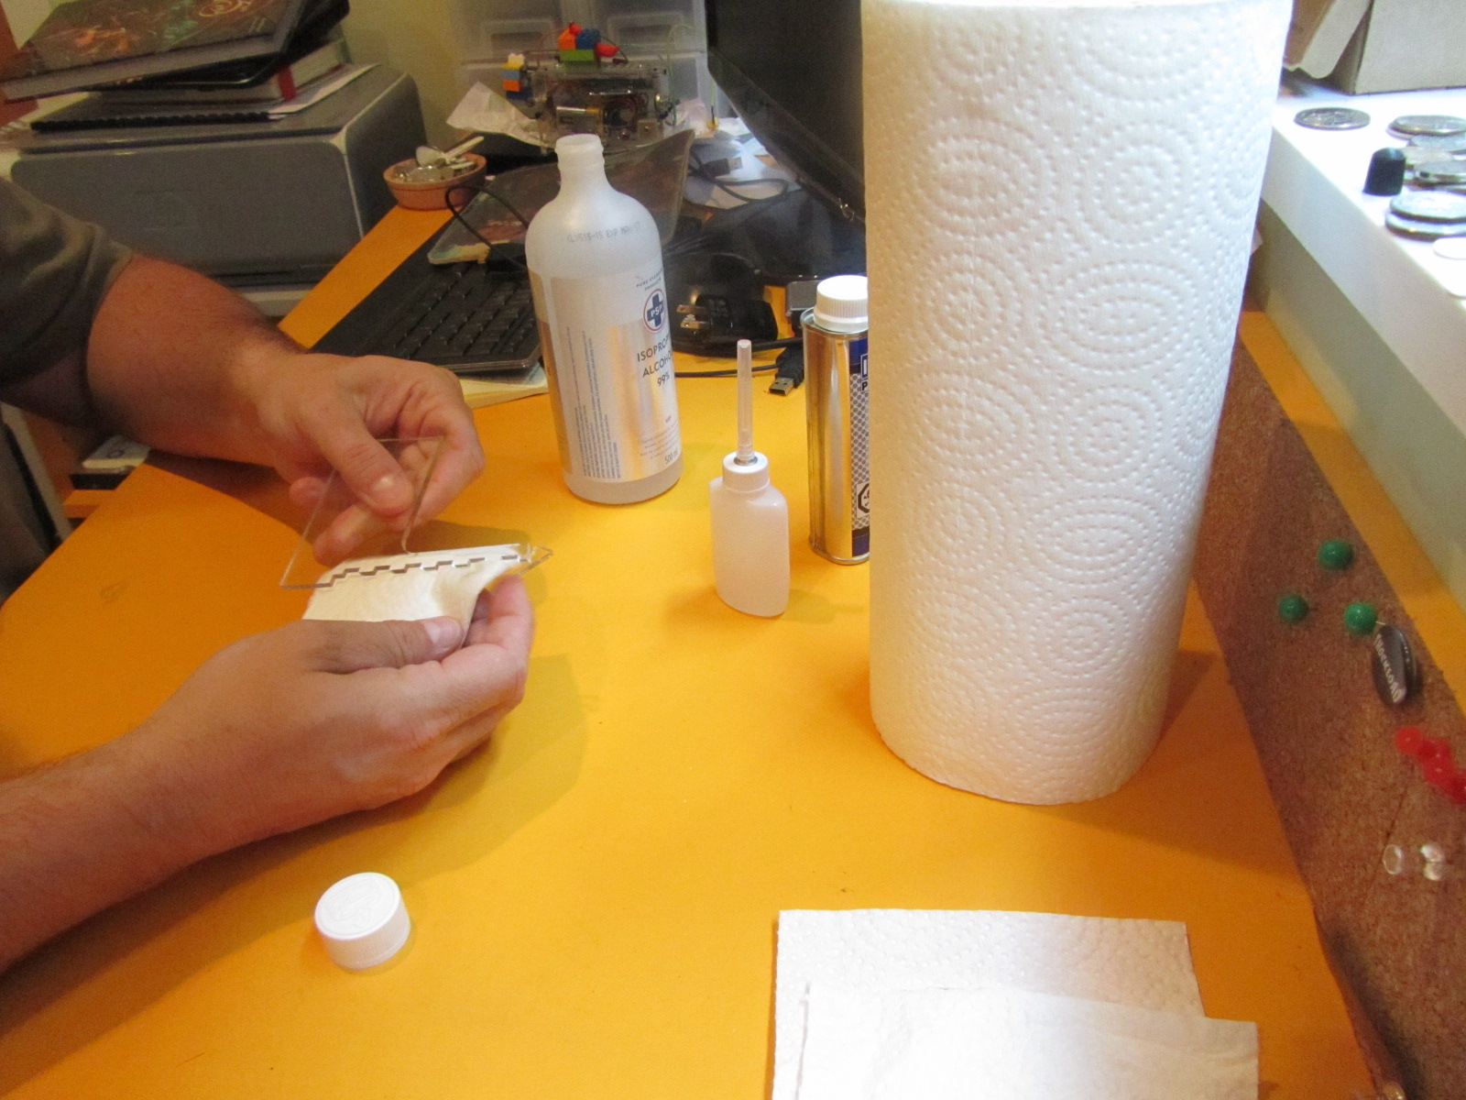

1. Fit the pieces together.

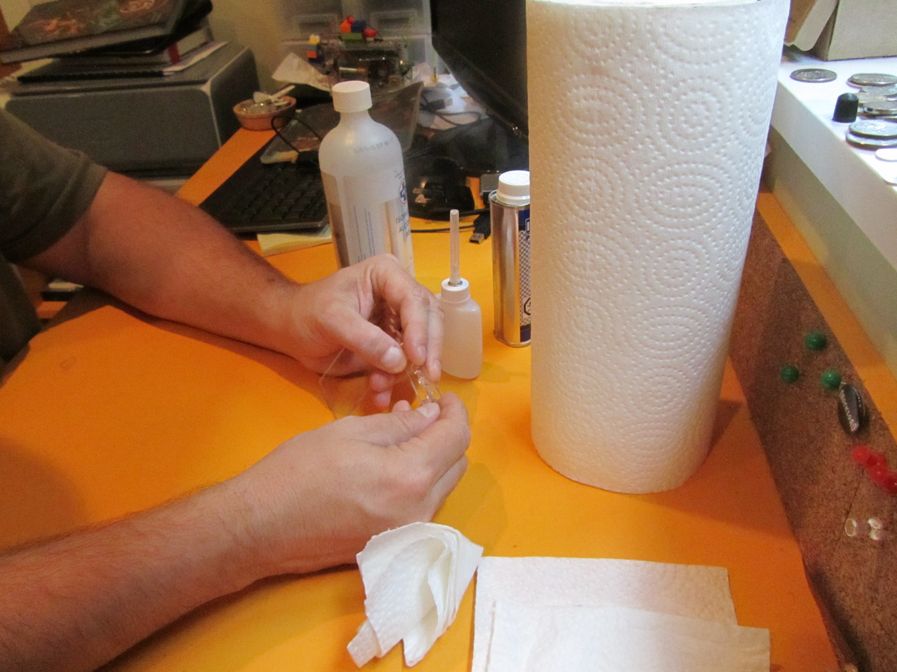

1. Apply the methylene chloride to the entire peremeter where the two pieces attach.

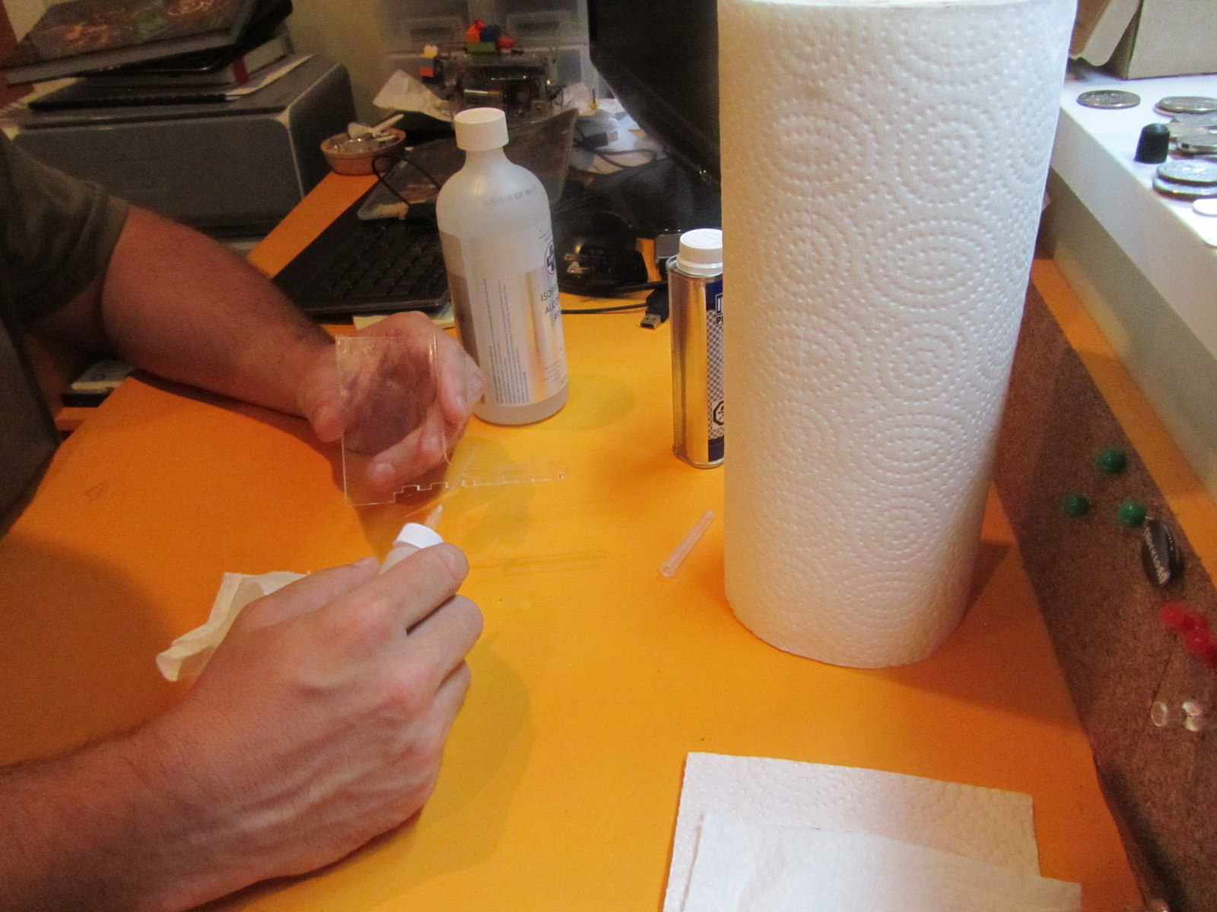

1. Hold in place for 5 minutes. Clamp if at all possible.

# Resources:

Additional information can be found at: